August 6th, 2006
Hi
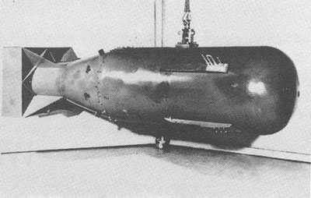
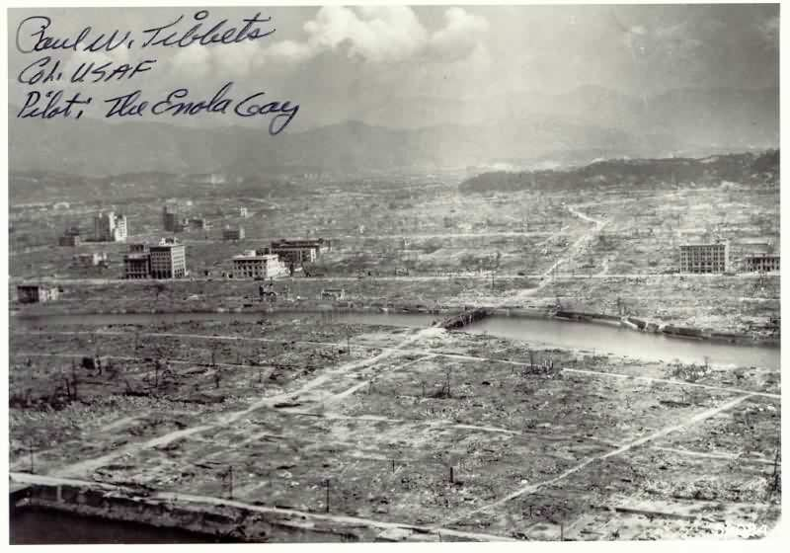
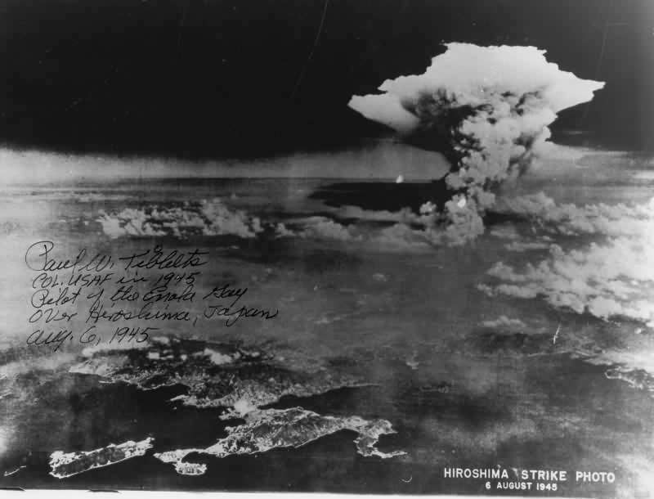
Today is the 61st anniversary of the dropping of the atomic bomb on Hiroshima. Some photographs of the dropping below, one signed by the pilot of the B-29 bomber that dropped the bomb.

Talking of anniversaries, I suppose, Gavin, you are celebrating having been married for about a year?
No swimming this week because of the wound in my lower leg, though swimming would probably still have been OK. The pool water is probably cooler too after a lot of heavy rain we have been having. So, used the gym instead. Did the first 30-min treadmill run for a long time but only at 10 km/h as I was having breathing difficulties. Later, I took one of the five remaining prednisilone/steroid tablets from 2000 (6 years ago!), which seemed to help. When I did more running later in the week, the breathing felt easier.
Just mentioned rain. The number 3 strong wind signal went up as a typhoon was moving across the South China Sea from the Philippines towards southern China. As it passed HK, the winds whipped up in this area and at the airport were ferocious. All flights at the airport were cancelled and at one stage there were about 3000 stranded passengers camping out at the airport as well as in the departure areas! There was just nowhere for them to go as all hotel rooms had been filled with other passengers. Winds measured near the big Buddha on Lantau were over 200 km/h at one stage and these were blowing straight across the runways. After the typhoon, it took a couple of days to remove the backlog of passengers. The observatory was criticised again this time were not raising the #8 signal. However, they did follow the criteria for raising and lowering signals. Moreover, in other parts of HK there was very little wind, as they were not exposed. Had the #8 gone up, the observatory would have been criticised for closing down all businesses. The poor guys there just can’t win!
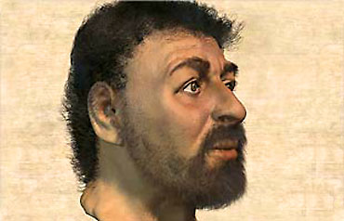
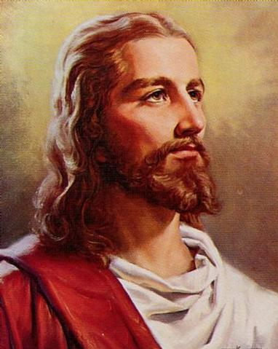
Friday was Leonie's birthday. Went to CUHK in the morning to collect medicine and the same time got the stitches on the foot wound removed. This saved going to a government outpatients clinic tomorrow, which was the day suggested when I had the operation. In the evening, I watched a repeat of the last episode of the BBC documentary 'Son of God' that included a reconstruction of Jesus' face. Look at the pictures on the right. Which one do you think is closer to what Jesus looked like? The one on the left is closer to the more traditional Western representations. However, the one on the right is probably closer to the real face. The producers of the documentary gave a ‘forensic artist’ at the University of Manchester a 1st century skull found in Jerusalem and asked him to reconstruct the face. (This person has also helped the police to solve crimes by reconstructing faces of people from their skulls.) He reconstructed the face and from historical evidence about hair and beards, the rest was completed. Very interesting documentary; it peeled away theology and 2000 years of myths and really shows what they guy was all about.
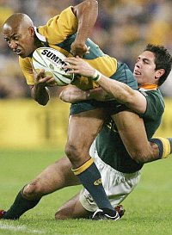
The tri Nations test yesterday was Australia versus South Africa. Everybody thought Australia would again thump SA as they did in their 49 -0 victory a few weeks ago. Well, Australia did win, 20 – 18, but only after a converted try late in the game.
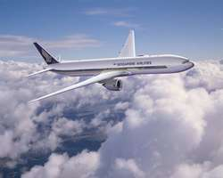
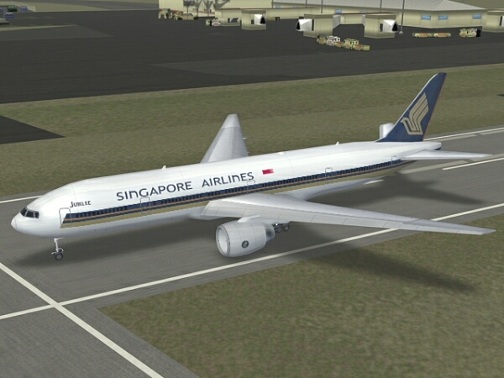
On Wednesday, I fly to Singapore to give a presentation of the O-Level Chemistry textbook I was asked to revise (as the original author had died). The presentation will be on Saturday but I will be there for a week. Flying with Singapore Airlines (on a ‘777’). Did all the booking and paying for the ticket online, the first time I have done that. Very convenient indeed. I was also able to choose the seat and menu online. On Tuesday, I will check-in online, though I don’t know how that works if there is luggage to check in and one has no physical ticket. Will find out when I arrive; just hope I don’t actually have to queue up which would defeat doing everything online.
That seems to be it for now. As I will be in Singapore next weekend, there will be no letter then.
Cheers

